**1. Area of triangle-**

<!DOCTYPE html>

<html>

<head>

  <title>Triangle Area Calculator</title>

</head>

<body>

  <label for="base">Base:</label>

  <input type="number" id="base"><br><br>

  <label for="height">Height:</label>

  <input type="number" id="height"><br><br>

  <button onclick="calculateArea()">Calculate Area</button>

  <p id="result"></p>

  <script>

    function calculateArea() {

      var base = prompt("Enter the base of the triangle:", "0");

      var height = prompt("Enter the height of the triangle:", "0");

      var area = (base * height) / 2;

      document.getElementById("result").innerHTML = "The area of the triangle is " + area;

    }

  </script>

</body>

</html>

</html>

Output-

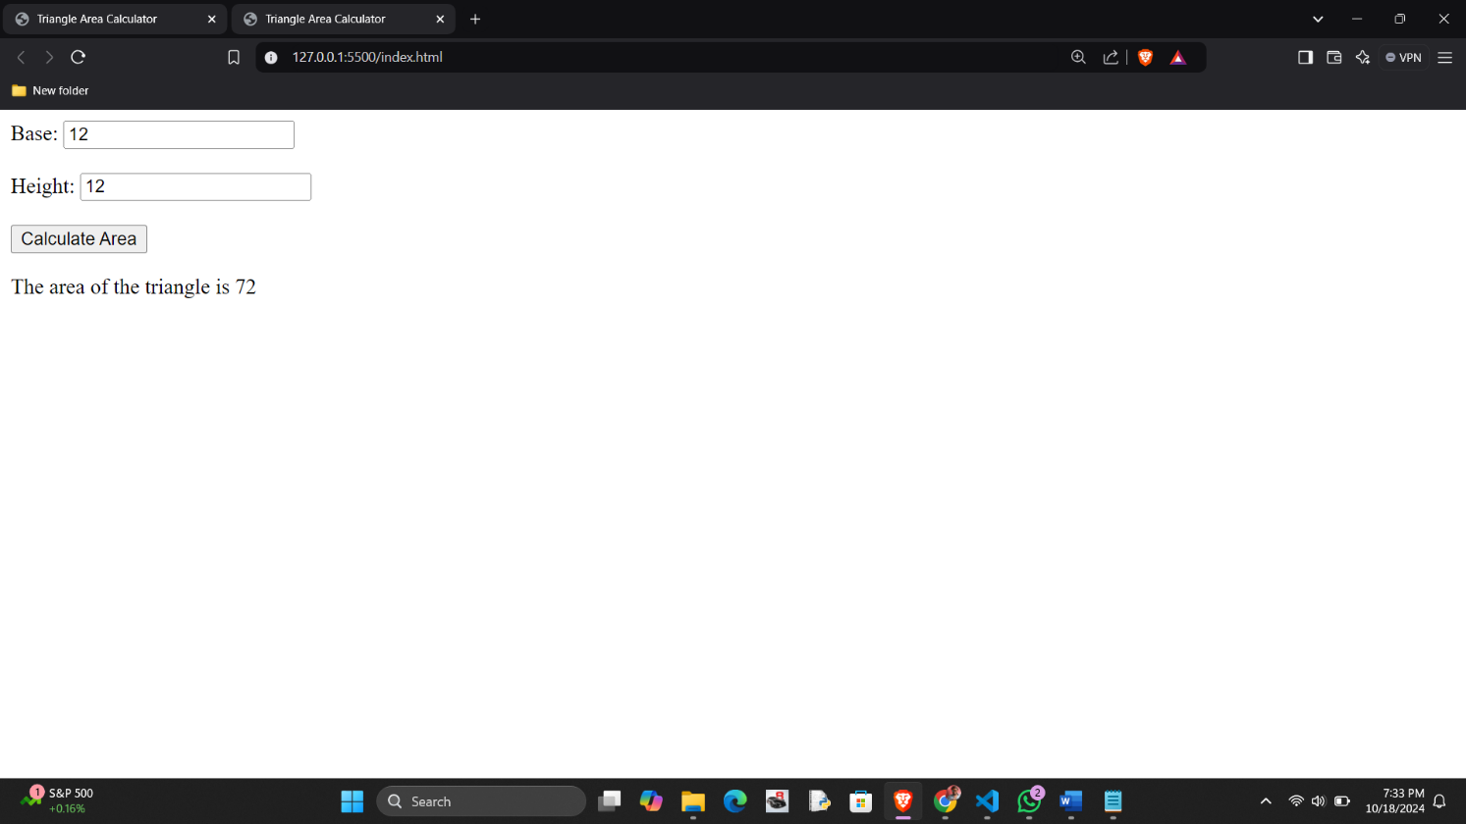

2. Area of recangle-

<!DOCTYPE html>

<html>

<head>

  <title>Rectangle Area Calculator</title>

</head>

<body>

  <label for="length">length:</label>

  <input type="number" id="length"><br><br>

  <label for=" width">Height:</label>

  <input type="number" id="width"><br><br>

  <button onclick="calculateArea()">Calculate Area</button>

  <p id="result"></p>

  <script>

    function calculateArea() {

      var length = prompt("Enter the length of the rectangle:", "0");

        var width = prompt("Enter the width of the rectangle:", "0");

      var area = length *  width;

      document.getElementById("result").innerHTML = "The area of the rectangle is " + area;

    }

  </script>

</body>

</html>

</html>

Output-

3. Area of circle-

<!DOCTYPE html>

<html>

<head>

  <title>Circle Area Calculator</title>

</head>

<body>

<h1>Circle Area Calculator</h1>

<label for="radius">Radius:</label>

<input type="number" id="radius"><br><br>

<button onclick="calculateArea()">Calculate Area</button>

<p id="result"></p>

<script>

    function calculateArea() {

        var radius = prompt("Enter the radius of the circle:", "0");

        // Convert input to number

        radius = parseFloat(radius);

        // Calculate area

        var area = Math.PI * radius * radius;

        // Display the result

        document.getElementById("result").innerHTML = "The area of the circle is: " + area.toFixed(2);

    }

</script>

</body>

</html>

Output –

